|  |  |
| --- | --- |
| **Module:** | ST2053 |
| **Name:** | Marcus Prunty |
| **Student Number:** | 118730509 |
| **Chapter:** | 2 |

**Maximum 2 pages! Do not delete the page number in the footer.**

**(a) Interpret the estimate of β3 .**

The slope of β3 = -0.5324021; this implies that with every point increase in BMI (kg/m^2) there is an expected 0.53 cm decrease in elbow breadth assuming all other variables are held constant

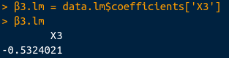

**(b) Interpret and comment on the value of R-squared.**

R-squared = 0.8940064: this indicates that the model explains 89 % of the variability around mean

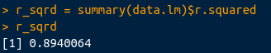

**(c) Test the hypothesis H0 : β1 = β2 = β3 = β4 = β5 = 0 against H1 : β1 , β2 , β3 , β4 , β5 not all 0 . Quote the value of the test statistic and the associated p-value. Explain the practical implications of your conclusion.**

F-statistic: 124.8311, p-value: < 2.2e-16

As the p-value < 0.05 returned true we reject H0 which means at least one of the variables should be included in the model



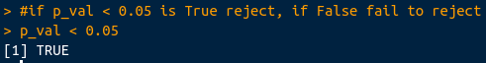

**(d) Can Elbow and Wrist be excluded from the current model?**

**Specify an appropriate hypothesis to test this. Quote the value of the test**

**statistic and the associated p-value.**

**Explain the practical implication of your conclusion.**

Testing H0 : β3 = β4 = 0, against H1 : β3 , β4 , not all 0

Yields a F-stat: 15.09858 and p-value: 2.937e-06

As the p-value < 0.05 returned true we reject H0 which means at least one of the variables should be included in the model





**(e) Is there evidence of collinearity in the current model?**

**What recommendation(s), if any, would you make?**

The r-squared values and calculated VIF do not show strong evidence of collinearity the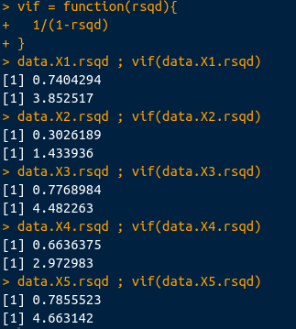 indication here is that each of the variables are independent and contribute uniquly to the model

**(f) Test the hypothesis H0 : β3 = 0, assuming all predictor variables in the**

**current model are uncorrelated.**